1.a. [Bookwork]
The answer here should indicate that the LED is a p-n junction. As it is a diode the device should exhibit an exponential rise in current with voltage due to the exponential rise in carrier diffusion across the junction as the forward bias increases, reducing opposing drift current term given by the built-in field. Very good students may also note that at high currents, to get the most light output from the LED, the resistive losses will play a role and consequently a linear rise in current with voltage may eventually be expected. Light is produced by the electron-hole pairs recombining, i.e. from electrons falling from the conduction band to valence band. Ideally a sketch showing the band structure of the device under forward bias and indicating the injection of electrons/holes across the junction should be included. The rate of recombination is equivalent to the current, therefore the light output should rise linearly with increasing current.
[8]

1.b. [Problem – varying degrees of difficulty for the different parts]
- External efficiency: (Applied Bookwork Problem)
We need to calculate the number of photons emitted per unit time:
The energy of one photon is given by: 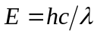, which is a given equation on the front of the paper.
As =530 nm, we have 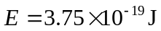 (or 2.35 eV)
Optical power is 40 mW, thus the number of photons emitter per second is 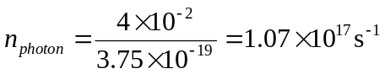
The number of recombination events per second is simply given by the number of electrons injected into the device: 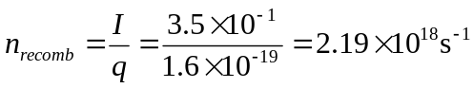
Thus the external efficiency is given by 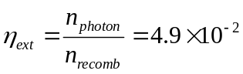or 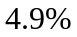
[4]
- Wall plug efficiency: (Applied Bookwork Problem)
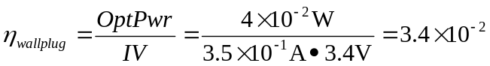or 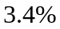
[2]
- More difficult bookwork
The difference is that the external efficiency considers only the conversion of current into optical emission, and pays no attention to voltage drops in other parts of the device, other than that across the junction. There are resistive losses at the contacts and in the p- and n- layers that lead to additional voltage drops which reduce the wall plug efficiency compared to that of the external efficiency of the device.
[2]

1.c. [Hidden]
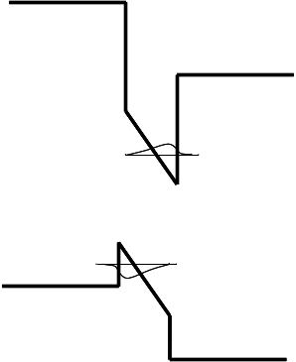
The quantum well will have at least one confined energy state for the electrons in the conduction band and for the holes in the valence band (ignoring the issues related to heavy and light holes which are not generally discussed in the course). The ground state should be as shown:
As the well width gets wider the efficiency will decrease as the electron and hole wavefunctions become more separated in space. The wavelength will shift to longer wavelength as the field will bring electron and hole states closer together in energy. Depending on the initial state there may also be reduced energy of confinement of the electron and hole wavefunction in the well as the well width increases too.
[4]

Question 2
- [Bookwork]
 is the quantum mechanical electron wavefunction
The equation is an energy balance and classically is the equivalent to saying that total energy = kinetic energy + potential energy.
[3]

- [Bookwork]
Setting up the problem, let us consider a potential well in 1-dimension from x=0 to x=L, where V in the well = 0. As the barriers are infinite the electron wavefunction cannot penetrate the barriers and hence our boundary conditions are that the wavefunction must equal zero at the well edges (x=0,L).
From examination of the equation we require a solution where the second derivative is the same as the original function: a sine wave solution is a valid function: hence use 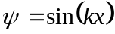. For equivalence we require 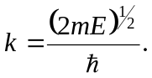
From the boundary conditions the solution must be a standing wave and hence 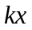must be an integral number of .
Hence 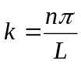and substituting and rearranging for E we get: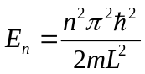.
[6]

- [Applied Example – partially hidden]
In the example we need to calculate confinement energy of the electron and the hole in the system, using the appropriate effective masses. The LED emission will occur between the lowest energy levels of the confined electron and hole states.
For the electron E_{1e} = 0.167 eV
For the hole E_{1h} = 0.020 eV
Adding in the bandgap means the total energy of the transition is 1.611 eV
The wavelength is given by 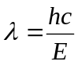=768 nm.
[4]
- [More difficult bookwork and hidden aspect]
For a finite well the electron and hole wavefunctions will penetrate the barriers. The boundary conditions are that at the edges of the well the wavefunction, , and its derivative, 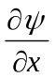, must be continuous. The effect of the finite barriers will be to lower the confinement energy of the lowest energy states and hence cause the emission to shift to longer wavelength.
[3]
- [Essentially hidden]
In this case the wavefunction between each of wells will overlap, providing a route to interaction between them. As a result due to the Pauli Exclusion Principle the Quantum Well energy levels will spread into a band (or mini-band). This will lead to a small red shift in the emission wavelength. In the same way as was carried out for deriving the bands of a bulk 1-D crystal (in notes) we can apply a Bloch function with appropriate boundary conditions to solve Schrodingers Equation.
[4]

Question 3
- [Bookwork – not the easiest]
The answer should consider the occupation probability for states in the CB and VB
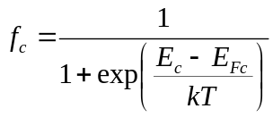 (and similar for f_{v})
The rate of generation of photons is given by (ignoring spontaneous emission)
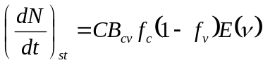
Similarly for absorption
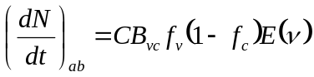
For net stimulated emission (assuming the Einstein B coefficients are equal)
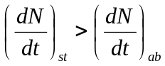
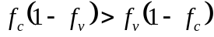
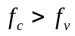
Substituting for the occupation probability and solving
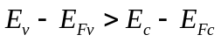
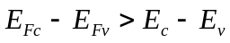
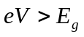
Thus for laser action the applied bias needs to exceed the emission bandgap
For a GaN laser at 420 nm the bandgap is 2.95 eV so the voltage must be greater than around 3V
[8]
- [ (i) Bookwork, (ii) essentially hidden, (iii) applied bookwork.]
  - The answer should describe how a laser is focussed to a spot on the disc where the presence or absence of pits cause changes in reflectivity, picked up by a photodiode giving a binary data stream. Lens should have a low numerical aperture to focus to as small a spot as possible. (Also has the advantage that due on the surface of the disc, separated by a protective coating remain out of focus)
[4]
  - Two from Low cost, long life, rugged design, small size
[2]
  - The size of the laser spot on the disc governs the minimum pit size which is controlled by the laser wavelength and numerical aperture of the lens. In the blu-ray system the laser is in the blue/violet (405nm) rather than the red (650 nm) giving the key benefit.
[2]
- [Hidden]
The key aspect the student needs to understand here is that semiconductor materials can be optically pumped (mentioned in lectures) but only by a source where the photon energy exceeds the semiconductor bandgap (which was not in this context). This means that only the Nd-YAG laser can excite the material. The emission from surface will be at the bandgap of the InGaAsP lower gap material at around 1.3 microns. It will be spontaneous as there is insufficient waveguiding and reflectivity to get lasing. From the edge if the intensity is high enough laser action should be observed.
[4]

Question 4
- [Bookwork]
  - To consider this we need to think about the spontaneous and stimulated emission rates. Spontaneous emission depends on the carrier density in the upper level, Stimulated emission depends additionally on the photon flux density in the material. Under normal circumstances the photon flux density is too small and spontaneous emission will dominate. In a cavity the emission is kept within the material allowing the photon flux energy density to build up to such a point that the stimulated emission can dominate giving laser action.
[3]
  - We need to consider the round trip gain of the cavity. Consider emission at a starting point near one mirror. Light will travel along the cavity and the intensity will increase by an amount exp(gL). Some light will be lost at the first mirror R_{1.} Then amplified by exp(gL) as it bounces back. Finally further emission will be lost due to the second mirror R₂. This means the round trip change in the light intensity will be given by R₁R₂exp(2gL). At threshold this value must equal 1. Rewriting gives the equation requested.
[3]
- [Applied bookwork/Hidden].
  - Refractive index should be assumed to be around 3.5. Refractive indes of air 1.
The equation is in the notes in the LED section (extraction efficiency) and needs to be adapted across, mentioned in notes: R=(n₂-n₁)²/(n₂+n₁)². The value should be around 31% depending on the exact value chosen
[3]
  - The cavity length can be any realistic value between around 0.2 mm and 2 mm. It is a simple substitution into provided equation to get threshold gain: For a 0.5 mm cavity a gain of 2300 m⁻¹ can be estimated for threshold.
[2]
- [Applied Bookwork / Hidden].
From the standing wave criterion mλ=2nL and assuming m is large we can get 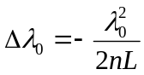
The laser operates at either 1.3 or 1.5 microns (here we will use 1.3 microns) and the values of n, L are as for part b.
In our case we have a value of around 5x10⁻¹⁰ m (of 0.5 nm) between the modes.
[4]
- [More difficult Bookwork].
In the laser the gain curve is much broader than the spacing between the modes. Typcially the gain width can be very roughly given by the linewidth of the spontaneous emission coming from the sample surface as if it was an LED and this is 10s of nm. As a result there are many potential modes that can exceed threshold and as the drive current is increased the laser may lase on more than one mode at once.
The method to prevent it can either be DFB, placing a grating in the cavity to modulate the refractive index or placing a slot in the cavity so that only a mode satisfying both cavities standing wave criterion will be allowed to lase.
[5]

